Name:Noor Sardar
ID:IU04-0123-0769
Course:Web Programming Languages (Lab)

“LAB TASK 1”
<!DOCTYPE html>
<html lang="en">
<head>
<meta charset="UTF-8">
<meta http-equiv="X-UA-Compatible" content="IE=edge">
<meta name="viewport" content="width=device-width, initial-scale=1.0">
<title>Resume</title>
<style>
body {
font-family: Arial, sans-serif;
background: #f4f4f4;
margin: 0;
padding: 0;
}
.container {
width: 60%;
margin: 40px auto;
background: #ffffff;
padding: 20px 40px;
border-radius: 10px;
box-shadow: 0 0 15px rgba(0,0,0,0.2);
}
h1, h2, h3 {
color: #333;
}
.center {
text-align: center;
}
.section-title {
margin-top: 25px;
border-bottom: 2px solid #555;
display: inline-block;
padding-bottom: 5px;
}
p {
line-height: 1.6;
}
</style>
</head>
<body>
<div class="container" style="display: flex; flex-direction: row; gap: 25px;">
<div style="width: 35%; text-align: center; background:#f7f9fc; padding: 20px; border-radius: 10px;">
<img src="c:\Users\TechDotPK\Downloads\Capture.PNG" width="140" style="border-radius:50%; border:3px solid #4a90e2; padding:4px; background:#fff; box-shadow:0 0 8px rgba(0,0,0,0.2);" alt="Profile Photo">
<h2 style="margin-top: 10px;">Noor Sardar</h2>
<p><strong>Email:</strong> noor.19305_n@iqra.edu.pk</p>
<p><strong>Phone:</strong> 03321903xxx</p>
<h3 style="margin-top:25px; border-bottom:2px solid #4a90e2; display:inline-block; padding-bottom:5px;">Skills</h3>
<p>HTML</p>
<p>CSS</p>
<p>JavaScript</p>
</div>

<div style="width: 65%;">
<h1 style="text-align:center; margin-bottom:10px;">Resume</h1>

<h2 class="section-title">About Me</h2>
<p style="text-align: justify;">My name is Noor Sardar, and I am a dedicated Computer Science student with a strong passion for technology and problem-solving. I am eager to apply my knowledge and skills in a professional environment, seeking opportunities to grow and contribute effectively as part of a dynamic team.</p>

<h2 class="section-title">Work Experience</h2>
<p><strong>Position:</strong> software Engineer</p>
<p><strong>Company:</strong> Google</p>
<p><strong>Years:</strong> 2024 - 2025</p>
<p><strong>Role:</strong> Front-End Developer</p>

<h2 class="section-title">Education</h2>
<p><strong>School:</strong> Junipers Academy</p>
<p><strong>College:</strong> Brilliant College</p>
<p><strong>University:</strong> Iqra University</p>
<p><strong>Degree:</strong> BSCS</p>
</div>
</div>
</body>
</html>
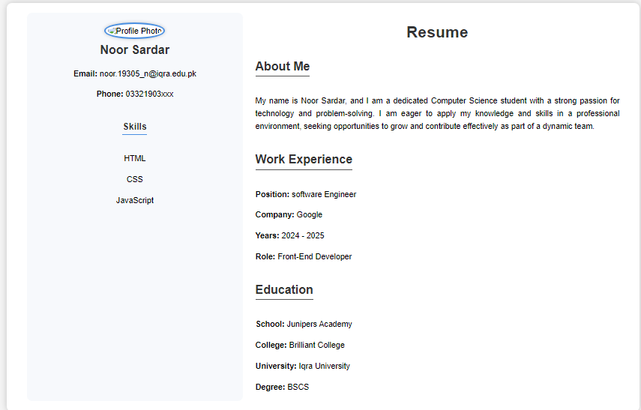
“LAB TASK 2”
<!DOCTYPE html>
<html lang="en">
<head>
<meta charset="UTF-8">
<title>SSC Marksheet</title>
<style>
body {
font-family: Arial, sans-serif;
background-color: #f0f0f0;
padding: 20px;
}

.marksheet {
width: 750px;
background: #ffffff;
margin: auto;
padding: 20px;
border: 2px solid #000;
}

h2, h3 {
text-align: center;
margin: 5px 0;
}

table {
width: 100%;
border-collapse: collapse;
margin-top: 15px;
}

td, th {
border: 1px solid #000;
padding: 8px;
text-align: center;
}

.info td {
border: none;
text-align: left;
padding: 6px;
}

.footer {
margin-top: 40px;
display: flex;
justify-content: space-between;
}

.sign {
text-align: center;
}
</style>
</head>
<body>

<div class="marksheet">
<h2>Secondary School Certificate (SSC)</h2>
<h3>Marksheet</h3>

<table class="info">
<tr>
<td><strong>Name:</strong> Noor Sardar</td>
<td><strong>Roll No:</strong> 19305</td>
</tr>
<tr>
<td><strong>Board:</strong> Kohat</td>
<td><strong>Year:</strong> 2023</td>
</tr>
</table>

<table>
<tr>
<th>Subject</th>
<th>Total Marks</th>
<th>Marks Obtained</th>
</tr>
<tr>
<td>Mathematics</td>
<td>100</td>
<td>75</td>
</tr>
<tr>
<td>English</td>
<td>100</td>
<td>73</td>
</tr>
<tr>
<td>Pakistan Studies</td>
<td>100</td>
<td>92</td>
</tr>
<tr>
<td>Islamiat</td>
<td>100</td>
<td>82</td>
</tr>
<tr>
<td>Chemistry</td>
<td>100</td>
<td>66</td>
</tr>
<tr>
<th>Total</th>
<th>500</th>
<th>388</th>
</tr>
</table>

<div class="footer">
<div class="sign">
_______________<br>
Teacher
</div>
<div class="sign">
_______________<br>
Principal
</div>
</div>
</div>

</body>
</html>


“LAB TASK 3”
<!DOCTYPE html>

<html lang="en">

<head>

<meta charset="UTF-8">

<meta http-equiv="X-UA-Compatible" content="IE=edge">

<meta name="viewport" content="width=device-width, initial-scale=1.0">

<title>Document</title>

<link href="https://cdn.jsdelivr.net/npm/bootstrap@5.3.8/dist/css/bootstrap.min.css" rel="stylesheet" integrity="sha384-sRIl4kxILFvY47J16cr9ZwB07vP4J8+LH7qKQnuqkuIAvNWLzeN8tE5YBujZqJLB" crossorigin="anonymous">

<script src="https://cdn.jsdelivr.net/npm/bootstrap@5.3.8/dist/js/bootstrap.bundle.min.js" integrity="sha384-FKyoEForCGlyvwx9Hj09JcYn3nv7wiPVlz7YYwJrWVcXK/BmnVDxM+D2scQbITxI" crossorigin="anonymous"></script>

</head>

<body><div class="container">

<form class="form-control" style="background-color: rgb(206, 206, 106);"> <h1>Sign Up</h1>

<label>FirstName</label>

<input class="form-control" placeholder="alex"><br>

<label >last Name</label>

<input class="form-control" placeholder="joe"><br>

<label>Email</label>

<input class="form-control" placeholder="example@gmail.com"><br>

<label>Password</label>

<input class="form-control" type="password" placeholder="eampel134"><br>

<h5>Date Of Birth:</h5>

<input type="date"><br>

<h5>Gender:</h5>

<label>Male</label>

<input type="radio">

<label>Female</label>

<input type="radio"><br><br>

<h5>Courses:</h5>

<label >WPL(LAB)</label>

<input type="checkbox"><br>

<label >Cloud Computing And Virtualization</label>

<input type="checkbox"><br>

<label >Machine Learning</label>

<input type="checkbox"><br><br>

<h5>Contact</h5>

<input class="form-control" type="number" placeholder="+92353662323"><br>

<h5>Profile Picture</h5>
<input type="file" >

<h5>Country</H5>

<select class="form-control">

<option>Country</option>

<option>Pakistan</option>

<option>United States</option>

<option>Canada</option>

<option>Japan</option>

</select> <br>

<h5>City</H5>

<select class="form-control">

<option>City</option>

<option>Karachi</option>
<option>Boston</option>
<option>Toronto</option>

<option>Tokyo</option>
</select> <br>

<button class="form-control btn btn-success">Submit</button>
</form></div>

</body>

</html>

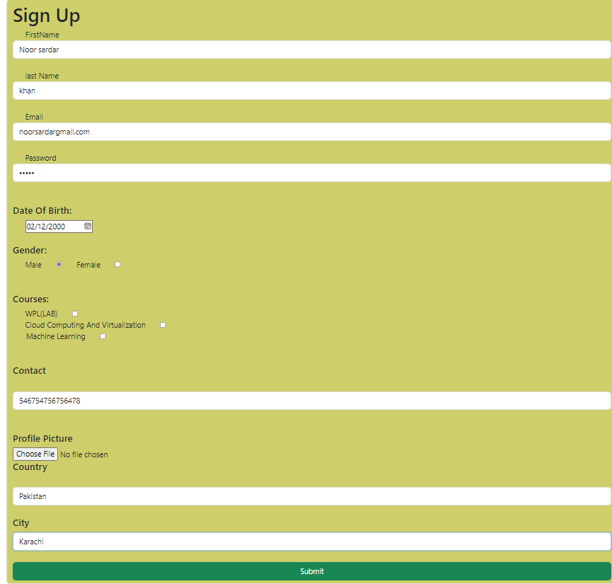
“Lab task 4”
<!DOCTYPE html>
<html lang="en">
<head>
<meta charset="UTF-8">
<title>Signup Form with Table</title>

</style>
</head>
<body>

<h2>Signup Form</h2>

<form id="signupForm">
<label>Name</label>
<input type="text" id="name" required>

<label>Email</label>
<input type="email" id="email" required>

<label>Password</label>
<input type="password" id="password" required>

<label>Gender</label>
<select id="gender" required>
<option value="">Select</option>
<option>Male</option>
<option>Female</option>
<option>Other</option>
</select>

<button type="submit">Sign Up</button>
</form>

<table>
<thead>
<tr>
<th>Name</th>
<th>Email</th>
<th>Password</th>
<th>Gender</th>
</tr>
</thead>
<tbody id="tableBody">
</tbody>
</table>

<script>
document.getElementById("signupForm").addEventListener("submit", function(event) {
event.preventDefault();

const name = document.getElementById("name").value;
const email = document.getElementById("email").value;
const password = document.getElementById("password").value;
const gender = document.getElementById("gender").value;

const tableBody = document.getElementById("tableBody");
const row = tableBody.insertRow();

row.insertCell(0).textContent = name;
row.insertCell(1).textContent = email;
row.insertCell(2).textContent = password;
row.insertCell(3).textContent = gender;

document.getElementById("signupForm").reset();
});
</script>

</body>
</html>
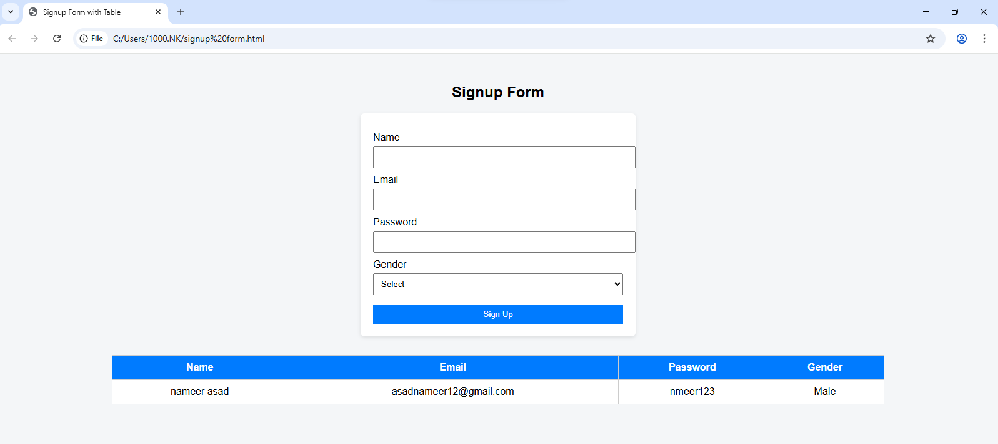
“LAB TASK 5”
<!DOCTYPE html>
<html>
<head>
<title>Facebook Signup</title>
</head>
<body>
<h2>Facebook Signup</h2>

<form onsubmit="return validate()" method="post" action="signup.php">
<input type="hidden" name="platform" value="Facebook">

Username: <input type="text" id="username" name="username"><br><br>
Email: <input type="email" id="email" name="email"><br><br>
Password: <input type="password" id="password" name="password"><br><br>

<button type="submit">Sign Up</button>
</form>

<script>
function validate() {
if (
document.getElementById("username").value === "" ||
document.getElementById("email").value === "" ||
document.getElementById("password").value.length < 6
) {
alert("All fields required & password must be 6+ characters");
return false;
}
return true;
}
</script>
</body>
</html>

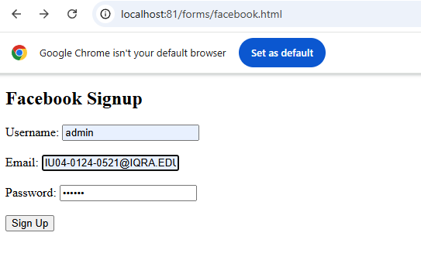

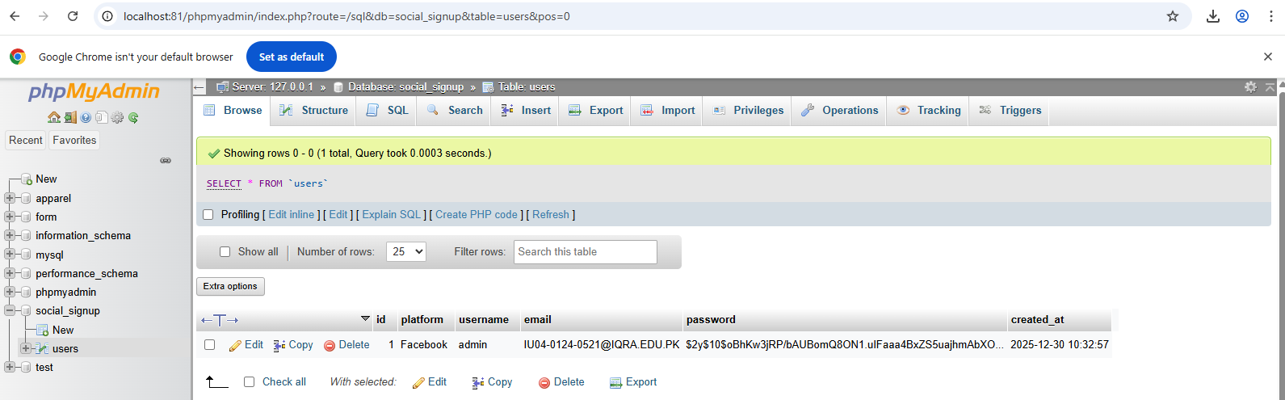

“LAB TASK 6”
<!DOCTYPE html>
<html lang="en">
<head>
<meta charset="UTF-8" />
<meta name="viewport" content="width=device-width, initial-scale=1.0" />
<title>Master Template</title>
<style>
.hero {
height: 70vh;
background: linear-gradient(
rgba(0, 0, 0, 0.6),
rgba(0, 0, 0, 0.6)
),
url("https://picsum.photos/1600/900") center/cover no-repeat;
}

body {
scroll-behavior: smooth;
}

.card {
border-radius: 12px;
}

</style>
<!-- Bootstrap 5 CSS -->
<link href="https://cdn.jsdelivr.net/npm/bootstrap@5.3.2/dist/css/bootstrap.min.css" rel="stylesheet">

<!-- Custom CSS -->
<link rel="stylesheet" href="style.css">
</head>
<body>

<!-- NAVBAR -->
<nav class="navbar navbar-expand-lg navbar-dark bg-dark">
<div class="container">
<a class="navbar-brand" href="#">MyTemplate</a>
<button class="navbar-toggler" type="button" data-bs-toggle="collapse" data-bs-target="#navbarNav">
<span class="navbar-toggler-icon"></span>
</button>

<div class="collapse navbar-collapse" id="navbarNav">
<ul class="navbar-nav ms-auto">
<li class="nav-item"><a class="nav-link active" href="#">Home</a></li>
<li class="nav-item"><a class="nav-link" href="#">About</a></li>
<li class="nav-item"><a class="nav-link" href="#">Projects</a></li>
<li class="nav-item"><a class="nav-link" href="#">Contact</a></li>
</ul>
</div>
</div>
</nav>

<!-- HERO SECTION -->
<section class="hero text-center text-light d-flex align-items-center">
<div class="container">
<h1 class="display-4">Master HTML Template</h1>
<p class="lead">Reusable • Responsive • Bootstrap 5</p>
<a href="#" class="btn btn-primary btn-lg">Get Started</a>
</div>
</section>

<!-- CONTENT SECTION -->
<section class="py-5">
<div class="container">
<div class="row g-4">
<div class="col-md-4">
<div class="card h-100 shadow-sm">
<div class="card-body">
<h5 class="card-title">Section One</h5>
<p class="card-text">Use this card for features, info, or content.</p>
</div>
</div>
</div>

<div class="col-md-4">
<div class="card h-100 shadow-sm">
<div class="card-body">
<h5 class="card-title">Section Two</h5>
<p class="card-text">Fully responsive with Bootstrap grid.</p>
</div>
</div>
</div>

<div class="col-md-4">
<div class="card h-100 shadow-sm">
<div class="card-body">
<h5 class="card-title">Section Three</h5>
<p class="card-text">Easy to customize and extend.</p>
</div>
</div>
</div>
</div>
</div>
</section>

<!-- FOOTER -->
<footer class="bg-dark text-light text-center py-3">
<p class="mb-0">&copy; 2025 Your Name. All rights reserved.</p>
</footer>

<!-- Bootstrap JS -->
<script src="https://cdn.jsdelivr.net/npm/bootstrap@5.3.2/dist/js/bootstrap.bundle.min.js"></script>
</body>
</html>

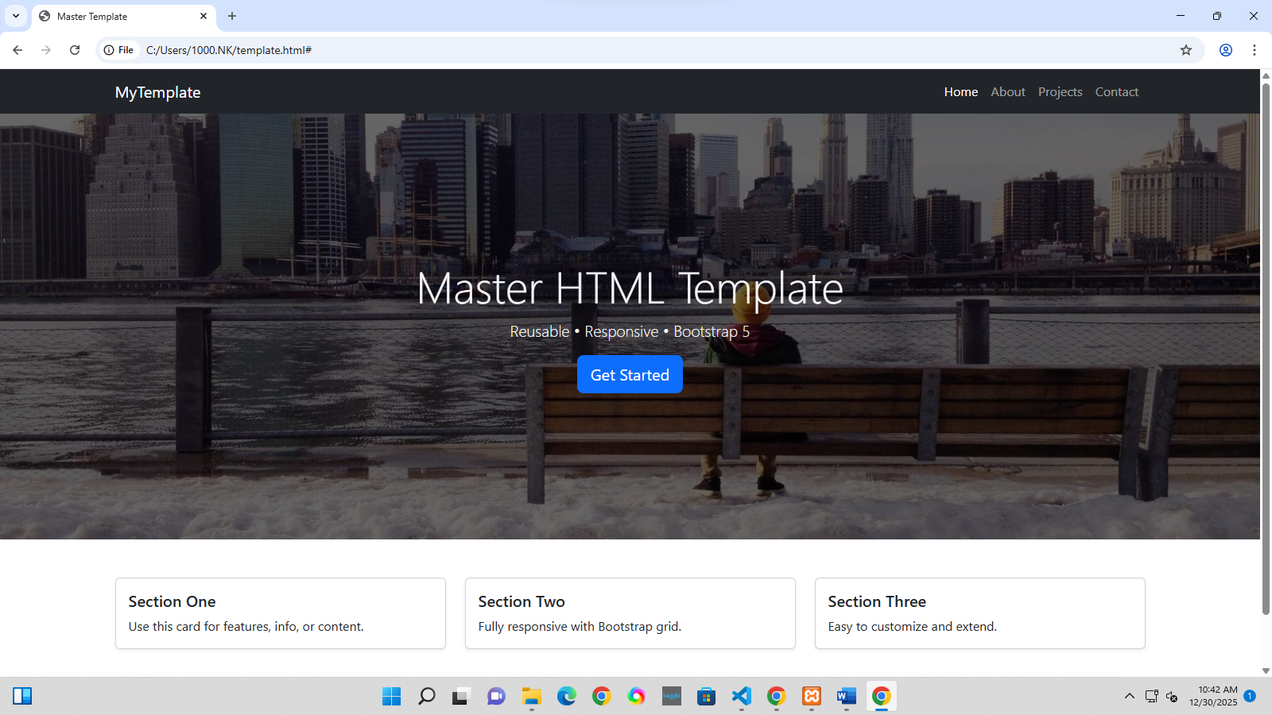

“LAB TASK 7”
<?php
include "db.php";

$action = $_POST['action'];

if ($action == "fetch") {
$result = $conn->query("SELECT * FROM students");
$data = [];

while ($row = $result->fetch_assoc()) {
$data[] = $row;
}

echo json_encode($data);
}

if ($action == "insert") {
$name = $_POST['name'];
$email = $_POST['email'];

$conn->query("INSERT INTO students (name, email) VALUES ('$name', '$email')");
}

if ($action == "delete") {
$id = $_POST['id'];
$conn->query("DELETE FROM students WHERE id=$id");
}

if ($action == "update") {
$id = $_POST['id'];
$name = $_POST['name'];
$email = $_POST['email'];

$conn->query("UPDATE students SET name='$name', email='$email' WHERE id=$id");
}
?>

<!DOCTYPE html>
<html lang="en">
<head>
<title>AJAX CRUD</title>
<link href="https://cdn.jsdelivr.net/npm/bootstrap@5.3.2/dist/css/bootstrap.min.css" rel="stylesheet">
</head>
<body class="p-4">

<div class="container">
<h2 class="mb-3">AJAX CRUD Operations</h2>

<input type="hidden" id="id">

<input type="text" id="name" class="form-control mb-2" placeholder="Name">
<input type="email" id="email" class="form-control mb-2" placeholder="Email">

<button class="btn btn-primary" onclick="insertData()">Save</button>
<button class="btn btn-warning" onclick="updateData()">Update</button>

<table class="table mt-4">
<thead>
<tr>
<th>Name</th>
<th>Email</th>
<th>Actions</th>
</tr>
</thead>
<tbody id="tableData"></tbody>
</table>
</div>

<script src="script.js"></script>
</body>
</html>

document.addEventListener("DOMContentLoaded", fetchData);

function fetchData() {
fetch("api.php", {
method: "POST",
body: new URLSearchParams({ action: "fetch" })
})
.then(res => res.json())
.then(data => {
let rows = "";
data.forEach(item => {
rows += `
<tr>
<td>${item.name}</td>
<td>${item.email}</td>
<td>
<button class="btn btn-sm btn-danger" onclick="deleteData(${item.id})">Delete</button>
<button class="btn btn-sm btn-info" onclick="editData(${item.id}, '${item.name}', '${item.email}')">Edit</button>
</td>
</tr>
`;
});
document.getElementById("tableData").innerHTML = rows;
});
}

function insertData() {
fetch("api.php", {
method: "POST",
body: new URLSearchParams({
action: "insert",
name: name.value,
email: email.value
})
}).then(() => {
fetchData();
name.value = "";
email.value = "";
});
}

function deleteData(id) {
fetch("api.php", {
method: "POST",
body: new URLSearchParams({ action: "delete", id })
}).then(fetchData);
}

function editData(id, n, e) {
document.getElementById("id").value = id;
name.value = n;
email.value = e;
}

function updateData() {
fetch("api.php", {
method: "POST",
body: new URLSearchParams({
action: "update",
id: document.getElementById("id").value,
name: name.value,
email: email.value
})
}).then(() => {
fetchData();
name.value = "";
email.value = "";
});
}

<?php
$conn = new mysqli("localhost", "root", "", "ajax_crud");

if ($conn->connect_error) {
die("Connection failed");
}
?>

